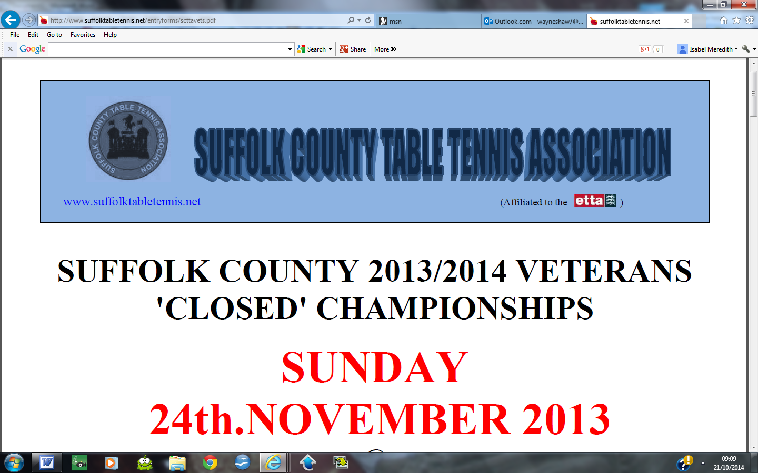

SUFFOLK COUNTY 2024/2025 JUNIOR 'CLOSED' CHAMPIONSHIPS

SUNDAY 23rd FEBRUARY 2025
@
Stowupland Sports Centre, Church Road, Stowupland, IP14 4BQ

CHAMPIONSHIPS ORGANISER
Wayne Shaw – wayneshaw7@msn.com

CHAMPIONSHIPS REFEREE
Play throughout will be on a knock-out basis with the exception of the
qualifying rounds which will be played in groups – subject to numbers – with
the winner and runner-up progressing to the knock-out rounds.
All competitors may only enter in their age category PLUS the immediate age category above them – if they wish

CLOSING DATE FOR ENTRIES:
SUNDAY 16TH FEBRUARY 2025

COMPLETED ENTRY FORMS INCLUDING FEES SHOULD BE SENT TO:

Wayne Shaw, 8 New Quay Terrace, Old Maltings Approach,
Melton, Woodbridge, IP12 1BF

Please make cheques payable to: Suffolk County Table Tennis Association

OR

BACS Payment to Suffolk County Table Tennis Association, Account No. 31655860, Sort Code 30-99-50, stating your name as the reference

ONLY ENTRY FORMS WITH FEES RECEIVED BY THE CLOSING DATE WILL BE ACCEPTED

Event scheduling will be carried out nearer the time when entry numbers are known.

The tournament will start at 9.00am and will aim to be complete by 5pm

Championships Regulations & Conditions:
* Completion and submission of the tournament entry form confirms agreement by the entrant to the regulations and conditions of these Championships.
* Entries will be accepted from any player registered for a club in membership of a league affiliated to Suffolk County T.T.A, or a registered member of a directly affiliated club, or a directly affiliated player, or attends any school under the authority of Suffolk County Council affiliated to Suffolk Schools TTA
*Every entrant MUST be affiliated as an associate or player member to Table Tennis England (see Table Tennis England website for details and procedure)
* Any player found to have played in a league or body not affiliated directly to Table Tennis England will not be allowed to enter.
* No entry will be accepted from or on behalf of any player who is ranked by or who has expressed a preference to be considered by any other county.
*Event age restrictions apply as follows:
Players entering the under 11’s events must have been born on or after 1st January 2014
Players entering the under 13’s events must have been born on or after 1st January 2012
Players entering the under 15’s events must have been born on or after 1st January 2010
Players entering the under 19’s events must have been born on or after 1st January 2006
All players may enter their age category plus the following age category if they wish
In addition, all players born on or after 1st January 2006 are entitled to enter the Pot Luck Doubles and Handicap singles events.
*All entry fees paid are non-refundable.
*All age category events will consist of best of 5 games, each game up to 11 points.
*The Handicap Singles matches will be 1 game, the winner being the first player to reach 31 points. Each competitor will be given a H'Cap rating commensurate with their ability. The match will commence at the score according to the relevant ratings.
*The Pot Luck Doubles will consist of best of 3 games, each game up to 11 points. Pairings will be made on the day with the strongest player paired with the least experienced and so on.
* Umpiring – Except during group matches where the umpire will be notified, all losing players up to the final will return the scoreboard and ball to the referee’s table and be available for umpiring the next scheduled game.
* Coaching of players and ‘Time Outs’ are allowed as per Table Tennis England & ITTF regulations.
* Dress code - as per Table Tennis England regulations.
* Bats – All rubbers must comply with Table Tennis England/ITTF.
*ALL players will be expected to honour their playing and umpiring commitments; if any player scratches simply because they have lost, or fails to umpire as required, they may not be allowed to enter subsequent SCTTA events.
*Players will be expected to play when called, so do not leave the venue at any time without the organiser’s permission.
* If you enter and subsequently are unable to play, you MUST notify the organiser as soon as you know that you cannot attend - someone not turning up on the day without notification can disrupt and spoil it for everybody.
*‘Knocking’ on vacant tables between matches will be at the discretion of the organiser.

Suffolk County Table Tennis – Code of Conduct

- Players will be punctual and polite and conduct themselves in a sporting manner
- A handshake will take place at the end of every match
- Verbal abuse towards an opponent, official or spectator is prohibited, including the use of foul language, before, during or after a match.
- Violent, threatening behaviour or bullying towards an opponent, official or spectator is prohibited. This includes any action, which causes, or has the potential to cause, physical or mental harm to another person. For example, deliberately throwing a bat or another object, or verbal threats made towards an opponent, breaking a ball, striking the table or any other equipment during play.
- Any disputes during a match will be referred to the umpire, or if applicable, the tournament referee, for the final decision, with which all players will abide without argument.
- Observers will not involve themselves in said disputes.

SUFFOLK COUNTY 2024/2025 JUNIOR 'CLOSED' CHAMPIONSHIPS

SUNDAY 23RD FEBRUARY 2025
@
Stowupland Sports Centre, Church Road, Stowupland, IP14 4BQ

ENTRY FORM

Please complete in ink using BLOCK CAPITALS and send with your remittance to:
Wayne Shaw, 8 New Quay Terrace, Old Maltings Approach, Melton, Woodbridge, IP12 1BF

Closing date for receipt of entries: SUNDAY 16TH FEBRUARY 2025

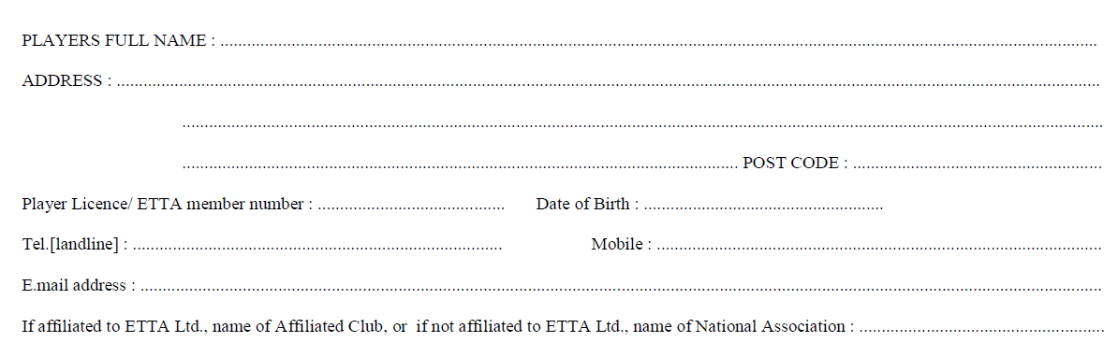
Events tick if entered male or female Entry fee
U11 £10.00 FOR 1ST AGE CATEGORY

U13 £5.00 FOR ADDITIONAL AGE CATEGORY
Cadets U15
Juniors U19
Handicap Singles PLEASE TICK IF ENTERING £ FREE

Pot Luck Doubles PLEASE TICK IF ENTERING £ FREE
TOTAL FEE ENCLOSED £
cheques to Suffolk County Table Tennis Association OR Bacs Payment to SCTTA, 30-99-50, 31655860

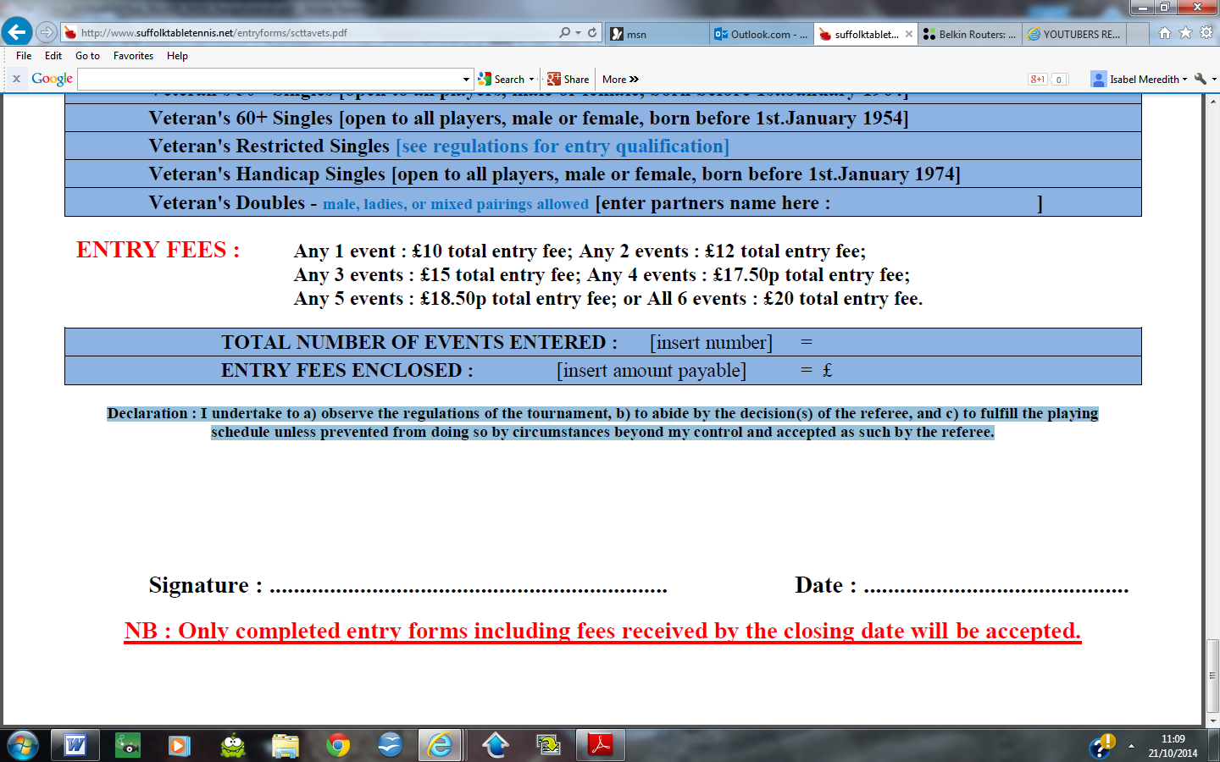
Declaration : I undertake to a) observe the regulations of the tournament, b) to abide by the decision(s) of the referee, and c) to fulfil the playing schedule unless prevented from doing so by circumstances beyond my control and accepted as such by the referee.

