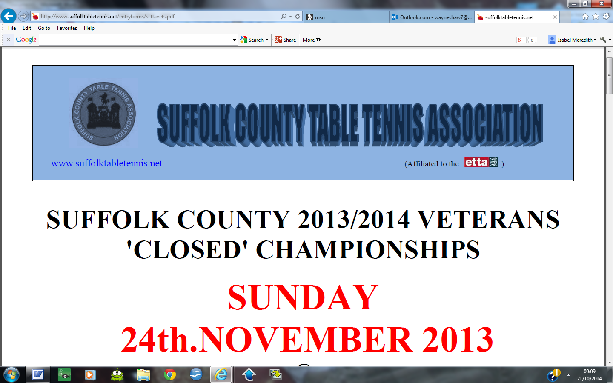

SUFFOLK COUNTY 2024/2025 VETERANS 'CLOSED' CHAMPIONSHIPS

SUNDAY 12TH JANUARY 2025
@

Stowupland Sports Centre, Church Road, Stowupland, IP14 4BQ

CHAMPIONSHIPS ORGANISER
Wayne Shaw – wayneshaw7@msn.com

(Sean Gridley 07879 408092 - will be running the event on the day)

CHAMPIONSHIPS REFEREE

Event scheduling will be carried out nearer the time when entry numbers are known.

The tournament will start at 9.00am and will be complete by 5pm

Please ensure you enter your email address so we can advise you of scheduling

CLOSING DATE FOR ENTRIES:
SUNDAY 5TH JANUARY 2025

COMPLETED ENTRY FORMS INCLUDING FEES SHOULD BE SENT TO:

Wayne Shaw, 8 New Quay Terrace, Old Maltings Approach, Melton, IP12 1BF

Please make cheques payable to: Suffolk County Table Tennis Association

OR

BACS Payment to Suffolk County Table Tennis Association, Account No. 31655860, Sort Code 30-99-50, stating your name as the reference

ONLY ENTRY FORMS WITH FEES RECEIVED BY THE CLOSING DATE WILL BE ACCEPTED

Championships Regulations & Conditions:
* Completion and submission of the tournament entry form confirms agreement by the entrant to the regulations and conditions of these Championships.
* Entries will be accepted from any player who was born or is resident in the County.
* Every entrant MUST be affiliated to Table Tennis England as a Compete or Compete + member (see Table Tennis England website for details and procedure)
* No entry will be accepted from or on behalf of any player who is ranked by or who has expressed a preference to be considered by any other county.
*Event age restrictions apply as follows
Players entering the over 40’s events must have been born before 1st January 1985
Players entering the over 60’s events must have been born before 1st January 1965
*All entry fees paid are non-refundable.
*All events (except for the Handicap singles) will consist of best of 5 games, each game up to 11 points.
*The Handicap Singles matches will be 1 game, the winner being the first player to reach 31 points (no deuce points). Each competitor will be given a H'Cap rating commensurate with their ability. The match will commence at the score according to the relevant ratings.
*Restricted singles event is open to both sexes, excluding the top 10 ranked veteran men, and any player deemed to be of least equal standard to an excluded player.
*The doubles event is open for both sexes and can be any combination of men, women or mixed.
* Umpiring – Except during group matches where the umpire will be notified, all losing players up to the final will return the scoreboard and ball to the referee’s table and be available for umpiring the next scheduled game.
* Due to time pressures, there will be NO ‘Time Outs’ allowed.
* Dress code - as per Table Tennis England regulations.
* Bats – All rubbers must comply with Table Tennis England/ITTF.
*ALL players will be expected to honour their playing and umpiring commitments; if any player scratches simply because they have lost, or fails to umpire as required, they may not be allowed to enter subsequent SCTTA events.
*Players will be expected to play when called, so do not leave the venue at any time without the organiser’s permission.
* If you enter and subsequently are unable to play, you MUST notify the organiser as soon as you know that you cannot attend - someone not turning up on the day without notification can disrupt and spoil it for everybody.
*‘Knocking’ on vacant tables between matches will be at the discretion of the organiser.

Suffolk County Table Tennis – Code of Conduct

- Players will be punctual and polite and conduct themselves in a sporting manner
- A handshake will take place at the end of every match
- Verbal abuse towards an opponent, official or spectator is prohibited, including the use of foul language, before, during or after a match.
- Violent, threatening behaviour or bullying towards an opponent, official or spectator is prohibited. This includes any action, which causes, or has the potential to cause, physical or mental harm to another person. For example, deliberately throwing a bat or another object, or verbal threats made towards an opponent, breaking a ball, striking the table or any other equipment during play.
- Any disputes during a match will be referred to the umpire, or if applicable, the tournament
referee, for the final decision, with which all players will abide without argument.
- Observers will not involve themselves in said disputes.

SUFFOLK COUNTY 2024/2025 VETERANS 'CLOSED' CHAMPIONSHIPS

SUNDAY 12TH JANUARY 2025
@
Stowupland Sports Centre, Church Road, Stowupland, IP14 4BQ

ENTRY FORM

Please complete in ink using BLOCK CAPITALS and send with your remittance to:
Wayne Shaw, 8 New Quay Terrace, Old Maltings Approach, Melton, IP12 1BF

Closing date for receipt of entries: SUNDAY 5TH JANUARY 2025

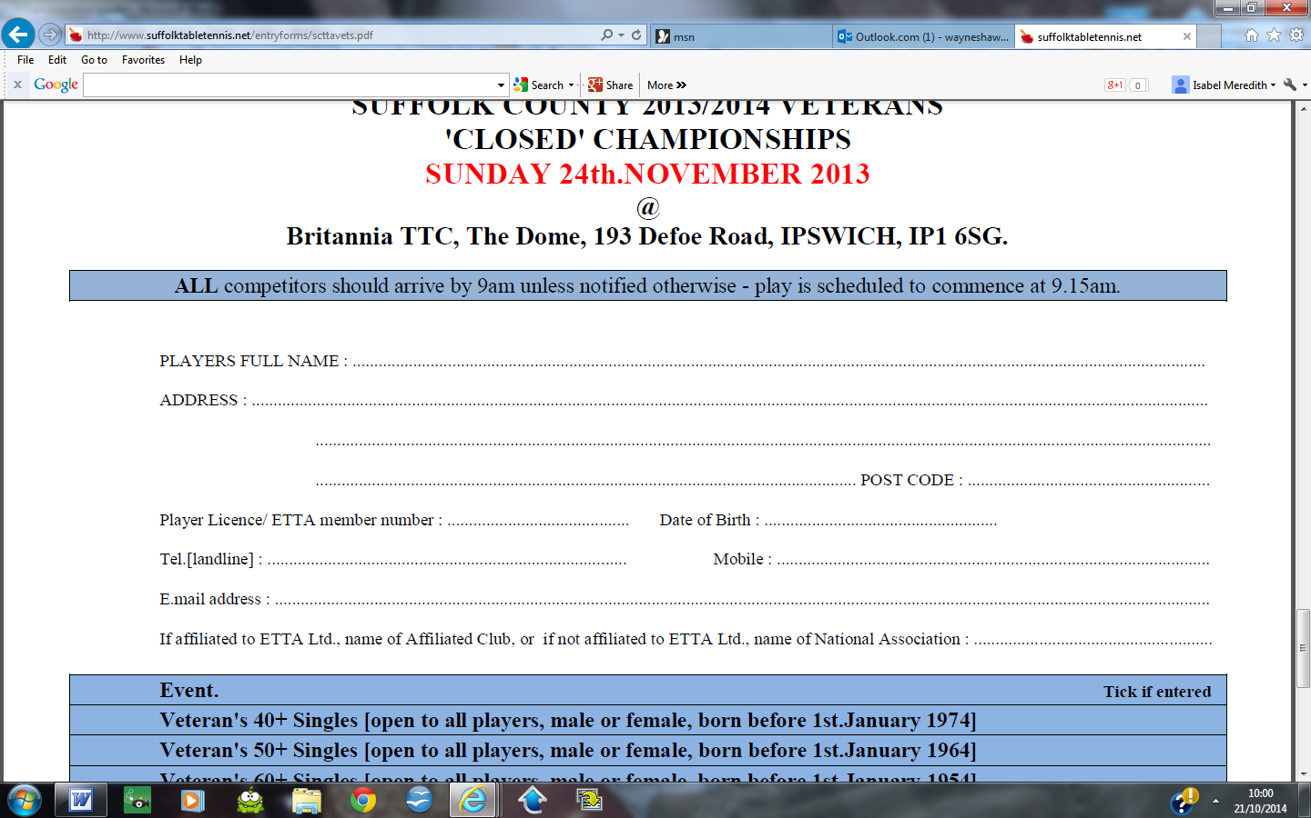
Events Tick if entering Doubles Partner Entry fee

Mens Over 40’s X £ 6.00

PLEASE TICK IF ENTERING £ FREE

Mens Over 60’s X £ 6.00

PLEASE TICK IF ENTERING £ FREE
Womens Over 40’s X £ 6.00

X £ 6.00

Womens Over 60’s X £ 6.00

X £ 6.00
Restricted Singles X £ 6.00

Handicap Singles X £ 5.00
Open Doubles £ 3.00 PER PLAYER
PLEASE TICK IF ENTERING £ FREE

FEE ENCLOSED £ cheques to Suffolk County Table Tennis Association OR BACS Payment to
Suffolk County Table Tennis Association, Account No. 31655860, Sort Code 30-99-50, stating your name as the reference

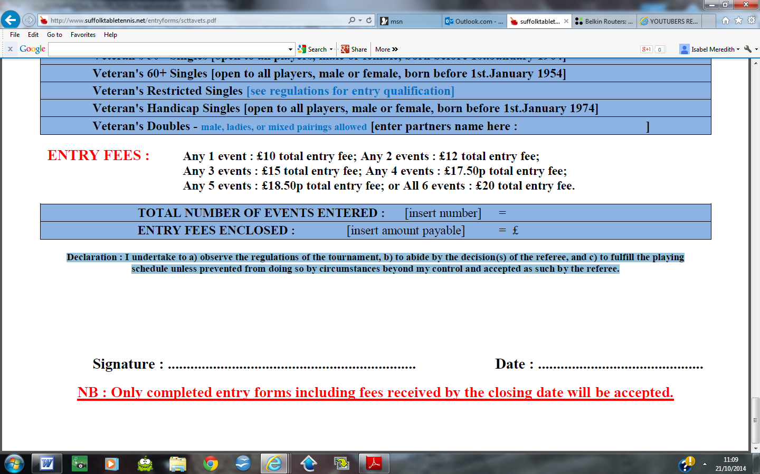
Declaration : I undertake to a) observe the regulations of the tournament, b) to abide by the decision(s) of the referee, and c) to fulfil the playing schedule unless prevented from doing so by circumstances beyond my control and accepted as such by the referee.

